GFCCE Portal Development

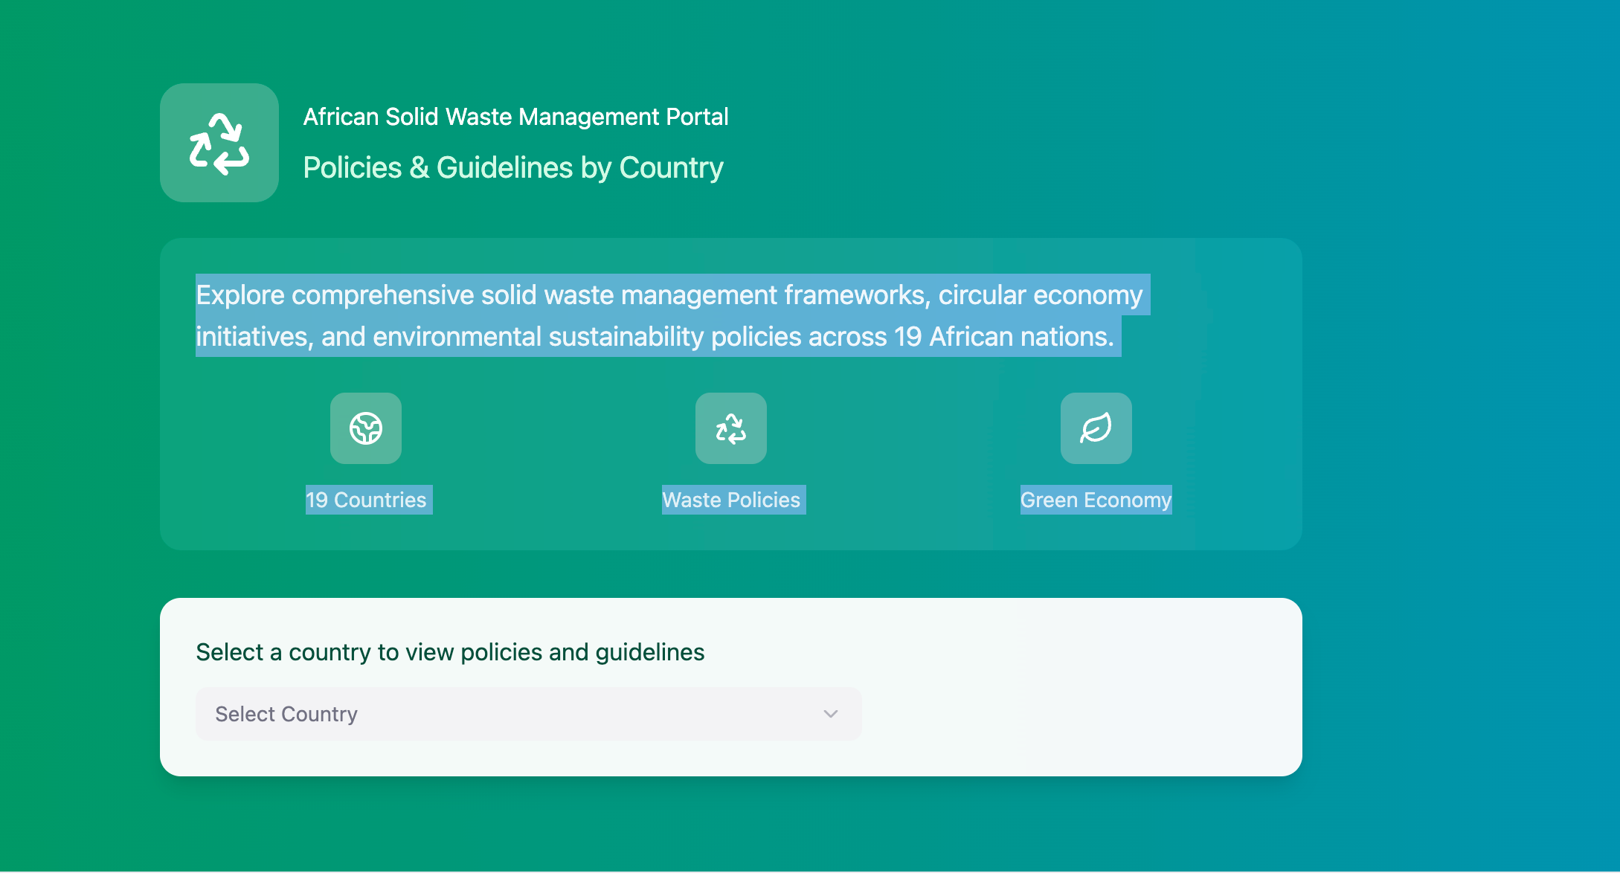

African Solid Waste Management Portal
Policies & Guidelines by Country

Explore comprehensive solid waste management frameworks, circular economy initiatives, and environmental sustainability policies across 19 African nations.
19 Countries Waste Policies Green Economy

- Front page/Launching page

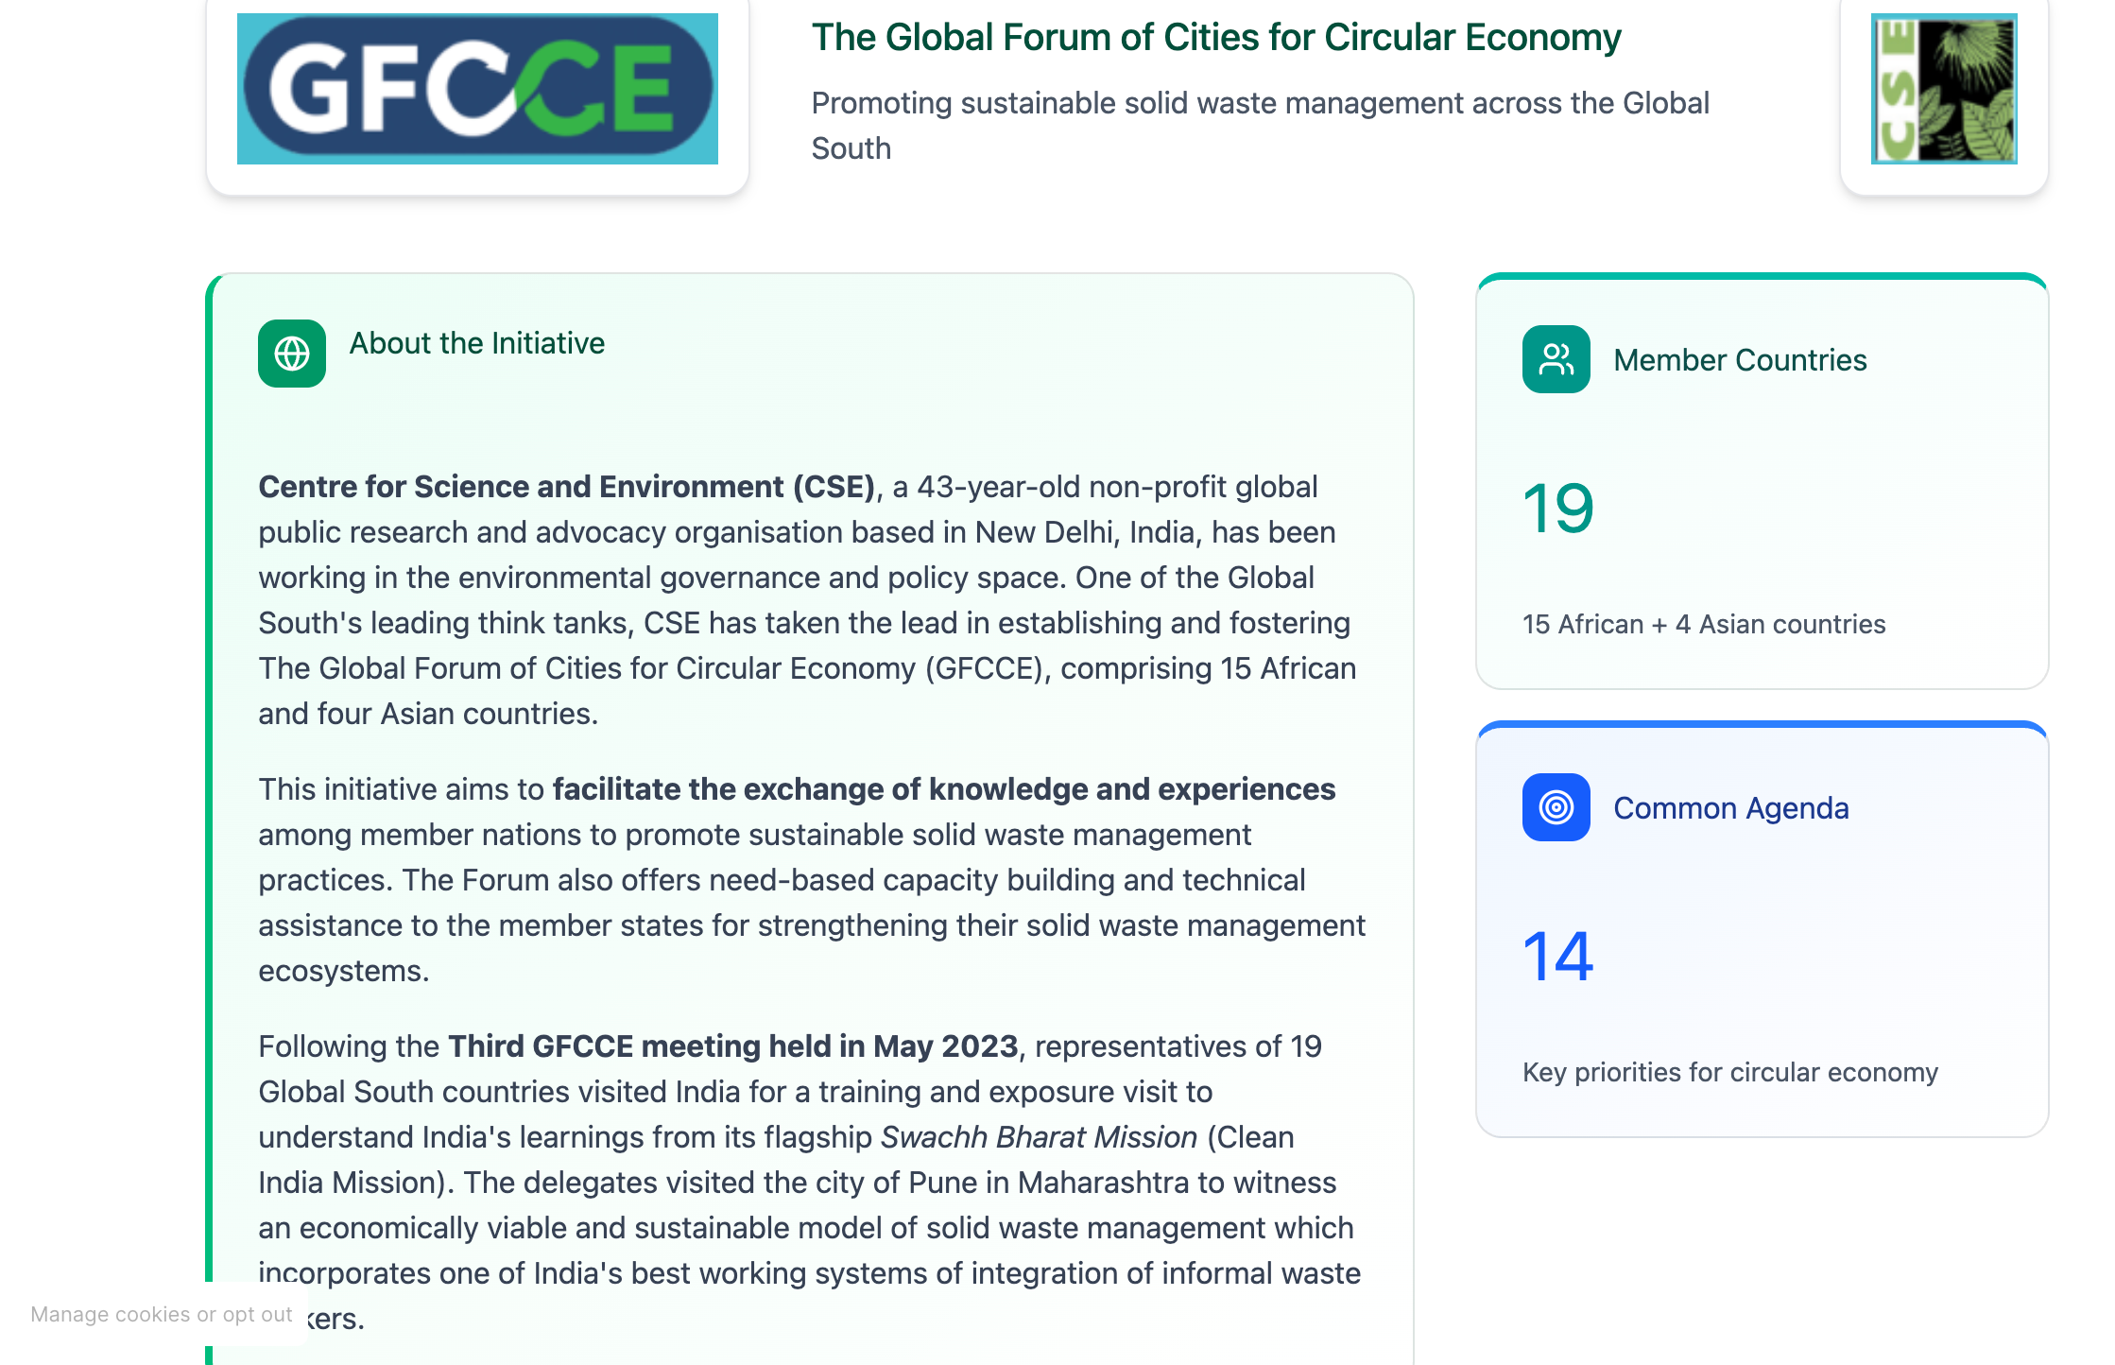

About the Initiative

Centre for Science and Environment (CSE), a 43-year-old non-profit global public research and advocacy organisation based in New Delhi, India, has been working in the environmental governance and policy space. One of the Global South's leading think tanks, CSE has taken the lead in establishing and fostering The Global Forum of Cities for Circular Economy (GFCCE), comprising 15 African and four Asian countries.

This initiative aims to facilitate the exchange of knowledge and experiences among member nations to promote sustainable solid waste management practices. The Forum also offers need-based capacity building and technical assistance to the member states for strengthening their solid waste management ecosystems.

Following the Third GFCCE meeting held in May 2023, representatives of 19 Global South countries visited India for a training and exposure visit to understand India's learnings from its flagship Swachh Bharat Mission (Clean India Mission). The delegates visited the city of Pune in Maharashtra to witness an economically viable and sustainable model of solid waste management which incorporates one of India's best working systems of integration of informal waste pickers.

Member Countries Common Agenda

19 14
15 African + 4 Asian countries Key priorities for circular economy

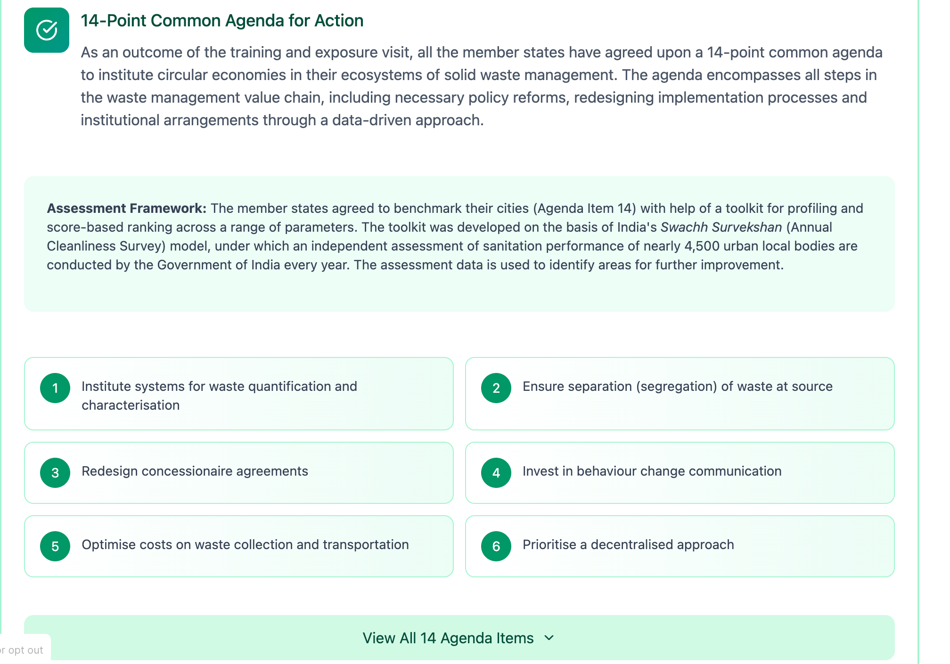

- Point Common Agenda for Action

As an outcome of the training and exposure visit, all the member states have agreed upon a 14-point common agenda to institute circular economies in their ecosystems of solid waste management. The agenda encompasses all steps in the waste management value chain, including necessary policy reforms, redesigning implementation processes and institutional arrangements through a data-driven approach.

Assessment Framework: The member states agreed to benchmark their cities (Agenda Item 14) with help of a toolkit for profiling and score-based ranking across a range of parameters. The toolkit was developed on the basis of India's Swachh Survekshan (Annual Cleanliness Survey) model, under which an independent assessment of sanitation performance of nearly 4,500 urban local bodies are conducted by the Government of India every year. The assessment data is used to identify areas for further improvement.

1 Institute systems for waste quantification and characterisation
2 Ensure separation (segregation) of waste at source
3 Redesign concessionaire agreements
4 Invest in behaviour change communication
5 Optimise costs on waste collection and transportation
6 Prioritise a decentralised approach
Integrate the informal sector
8 Manage bulk waste generators
9 Use municipal bye-laws as a legal instrument to address segregation and home composting
10 Ban dumping of biodegradable and combustible waste
11 Implement "polluter pays" principle for plastic waste management
12 Impose landfill tax
13 Close existing dumpsites
14 Develop tools for setting up a baseline to rank the cities in the Global South

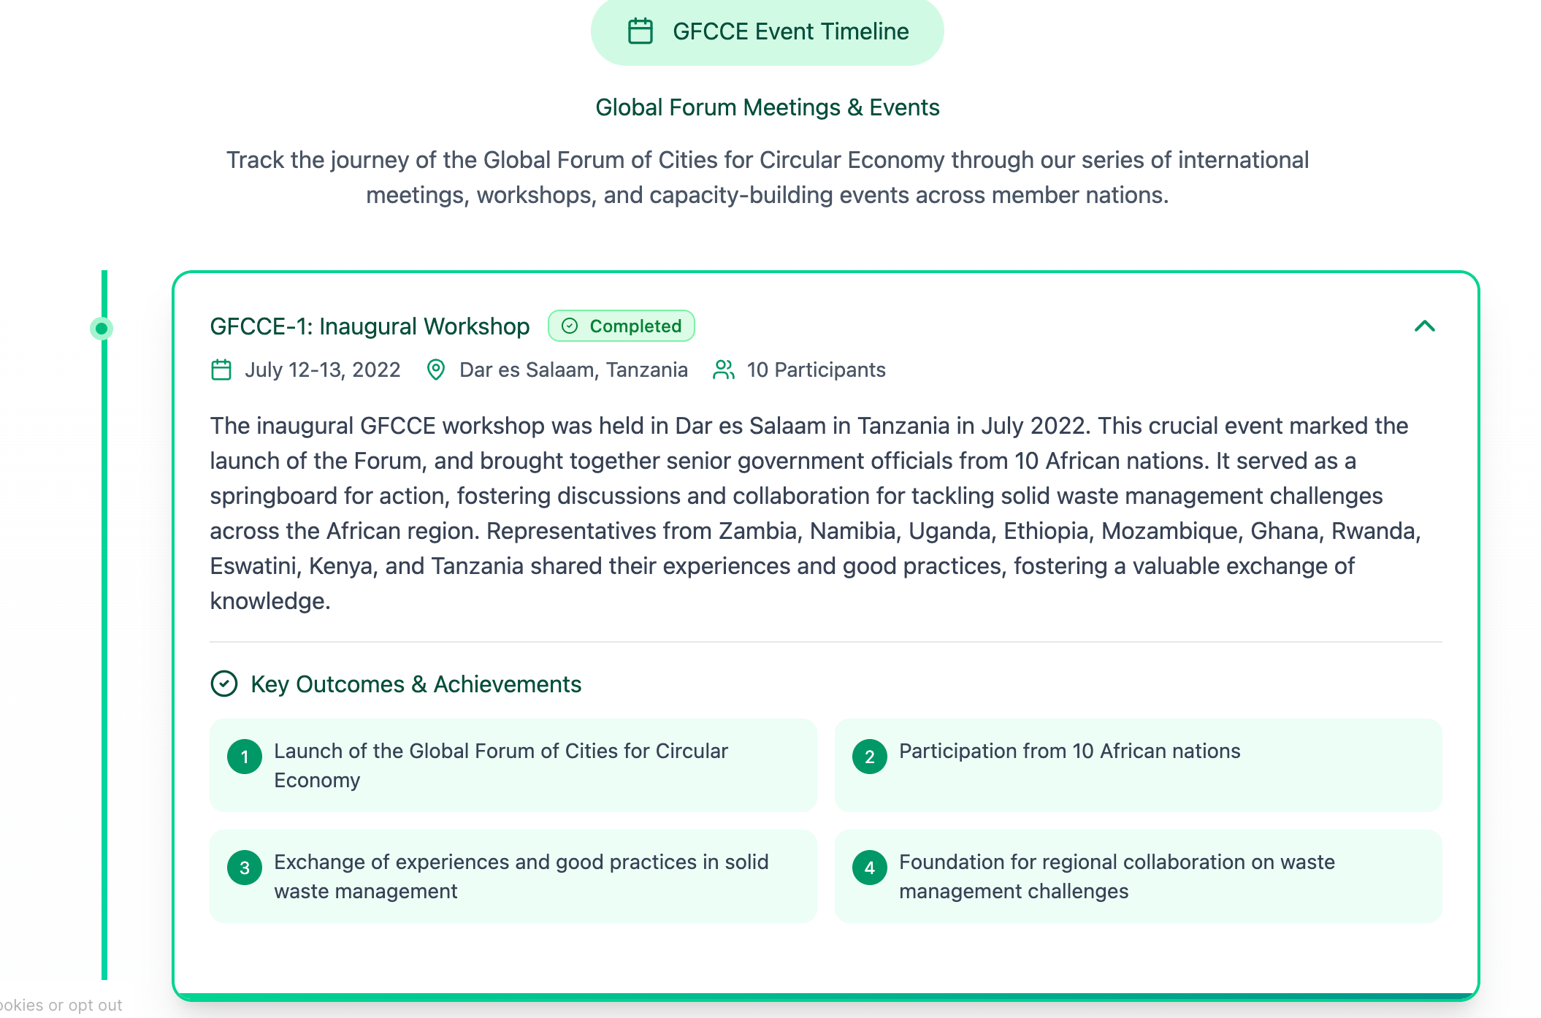

GFCCE-1: Inaugural Workshop Completed
July 12-13, 2022 Dar es Salaam, Tanzania 10 Participants

The inaugural GFCCE workshop was held in Dar es Salaam in Tanzania in July 2022. This crucial event marked the launch of the Forum, and brought together senior government officials from 10 African nations. It served as a springboard for action, fostering discussions and collaboration for tackling solid waste management challenges across the African region. Representatives from Zambia, Namibia, Uganda, Ethiopia, Mozambique, Ghana, Rwanda, Eswatini, Kenya, and Tanzania shared their experiences and good practices, fostering a valuable exchange of knowledge.

Key Outcomes & Achievements
1 Launch of the Global Forum of Cities for Circular Economy
2 Participation from 10 African nations
3 Exchange of experiences and good practices in solid waste management
4 Foundation for regional collaboration on waste management challenges

GFCCE-2: Plastic Waste Management Focus Completed
January 23-25, 2023, Dar es Salaam, Tanzania 9 Participants
The second GFCCE workshop, held in Dar es Salaam once again in January 2023, marked a significant step forward for the Forum. It brought together delegates from nine African countries alongside distinguished guests like the High Commissioner of India in Tanzania. CSE released another report titled "Plastic Waste Management in Africa: An Overview," a secondary scoping research on the state of plastic waste management systems and practices across 15 African nations.
Key Outcomes & Achievements
1 Release of "Plastic Waste Management in Africa: An Overview" report
2 Scoping research on plastic waste management across 15 African nations
3 Participation of High Commissioner of India in Tanzania
4 Strengthened partnerships between African countries and India

GFCCE-3: Training & Exposure Visit to India Completed
May 1-5, 2023 India, India 19 Participants

CSE hosted the third GFCCE workshop-cum-exposure visit with senior representatives from 19 countries and India for a south-south cooperation endeavour. The event included a comprehensive training on sustainable solid waste management and an exposure visit to showcase Indian best practices under the flagship Swachh Bharat Mission 2.0. The workshop provided a platform for city representatives to share knowledge and learn from experts. Participants delved into topics like waste reduction, segregation at source, collection and transportation, processing and recycling various models of sustainable waste management practices present in India under SBM 2.0

Key Outcomes & Achievements
1 Comprehensive training on sustainable solid waste management
2 Exposure visit to Indian best practices under Swachh Bharat Mission 2.0
3 South-south cooperation between 19 countries
4 Knowledge sharing on waste reduction, segregation, collection, and processing

GFCCE-4: Best Practices Exchange Completed
November 21-23, 2023 Accra, Ghana
40 Participants

The Fourth GFCCE meet successfully concluded in Accra, Ghana, in November 2023. Forty representatives from 14 African nations other than the host country Ghana participated, discussing best practices and solutions for solid waste management. Participants visited the Accra Compost and Recycling Plant, one of Ghana's premier state-of-the-art integrated solid waste management facilities. In addition, participants also engaged in discussions on plastic pollution, dumpsite remediation and community engagement.
Key Outcomes & Achievements
1 Visit to Accra Compost and Recycling Plant
2 Discussions on plastic pollution and dumpsite remediation
3 Community engagement strategies
4 Exchange of best practices from 14 African nations

GFCCE-5: Toolkit Capacity Building Workshop Completed
February 5-7, 2024 Dar es Salaam, Tanzania
18 Participants

Following the Fourth GFCCE event, the National Environment Management Council (NEMC) of Tanzania agreed to roll out the toolkit among 12 of its selected cities in the first leg – among them the six largest cities of the country: Dar es Salaam, Arusha, Dodoma, Mwanza, Mbeya and Tanga city, and five relatively smaller municipal authorities, namely Ubungo, Kigamboni, Temeke, Kinondoni and Ilemela. In addition, the semi-autonomous island of Zanzibar was also brought on board. The NEMC and CSE co-hosted a capacity building workshop in Dar es Salaam with officials from 12 cities and six regional administrations. The event focused on elements of sustainable solid waste management practices coupled with detailed orientation of the ranking and profiling toolkit. CSE also demonstrated an open source mobile application in Swahili for ease of implementation, data management and automation in analysis of collected data for meaningful assessment and interpretation of the current situation through an array of indicators.
Key Outcomes & Achievements
1 Rollout of assessment toolkit in 12 Tanzanian cities including Zanzibar
2 Capacity building for officials from 12 cities and 6 regional administrations
3 Introduction of open source mobile application in Swahili
4 Training on ranking and profiling toolkit for sustainable waste management

GFCCE-6: Circular Economy Principles Workshop Completed
August 7-8, 2024 Ezulwini, Eswatini
15 Participants

The 6th Global Forum of Cities for Circular Economy (GFCCE) workshop took place on August 7-8, 2024, in Eswatini, organized jointly by the Centre for Science and Environment (CSE) and the Eswatini Environment Authority (EEA). Held at Hotel Royal Villas, Ezulwini, the workshop gathered representatives from various ministries, 14 municipalities, and one model village (inkundla) to enhance their capacity in sustainable solid waste management. The event aimed to equip local officials and stakeholders with skills aligned with circular economy principles, drawing insights from India's Clean India Mission and emphasizing municipal bye-laws, biodegradable waste processing, dry waste management, and the Global Plastic Treaty. A key highlight was the introduction of a toolkit by CSE to assess and rank sanitation performance, marking a significant step supported by a Memorandum of Understanding (MoU) signed between CSE and EEA to advance sustainable waste management in Eswatini.

Key Outcomes & Achievements
1 MoU signed between CSE and Eswatini Environment Authority
2 Capacity building for 14 municipalities and one model village
3 Introduction of toolkit to assess and rank sanitation performance
4 Focus on municipal bye-laws, biodegradable waste, and Global Plastic Treaty

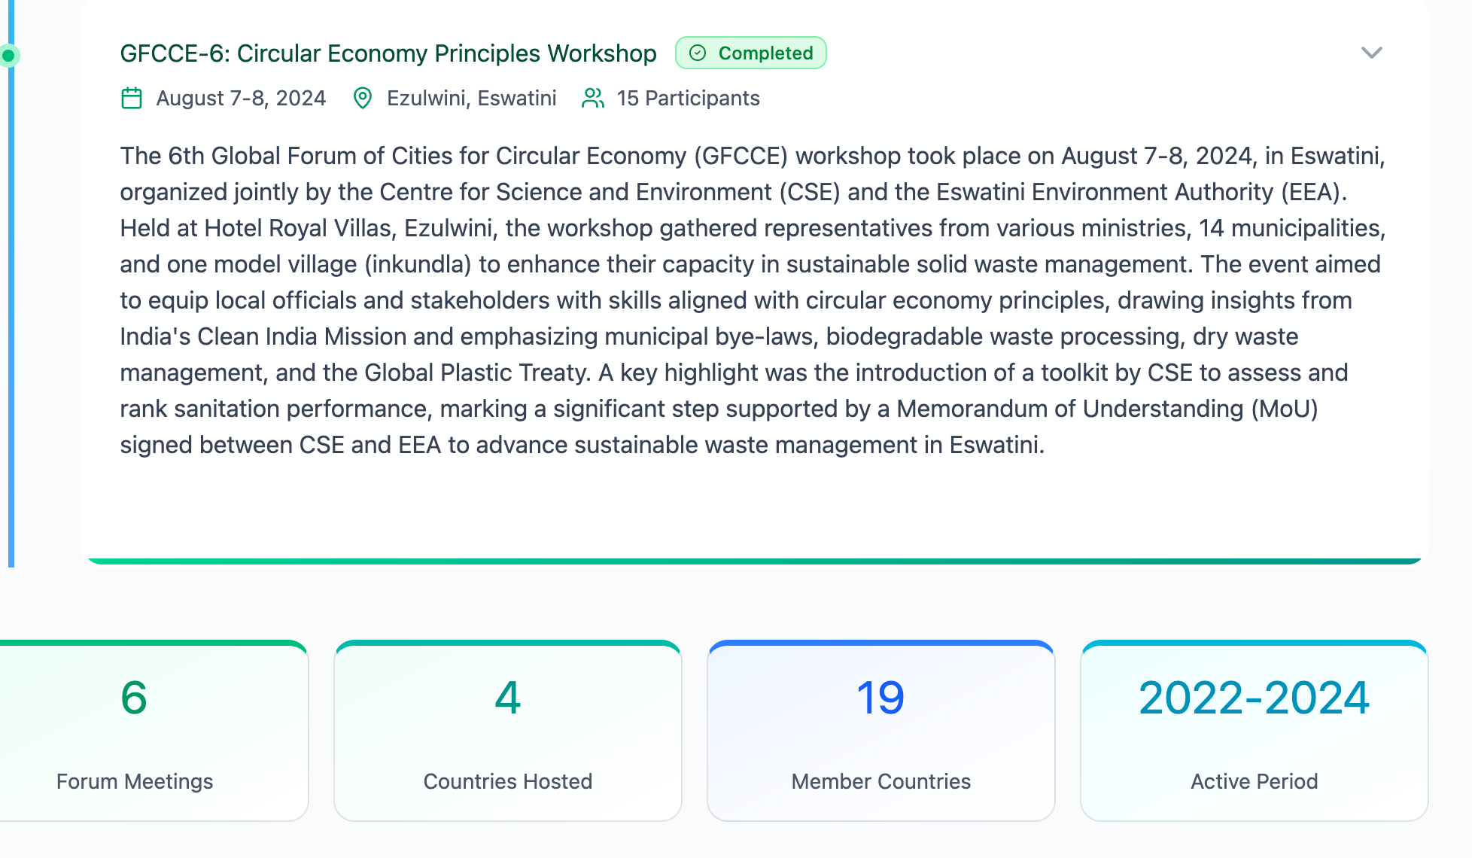

6 orum Meetings 4 Countries Hosted 19Member Countries

2022-2024
Active Period

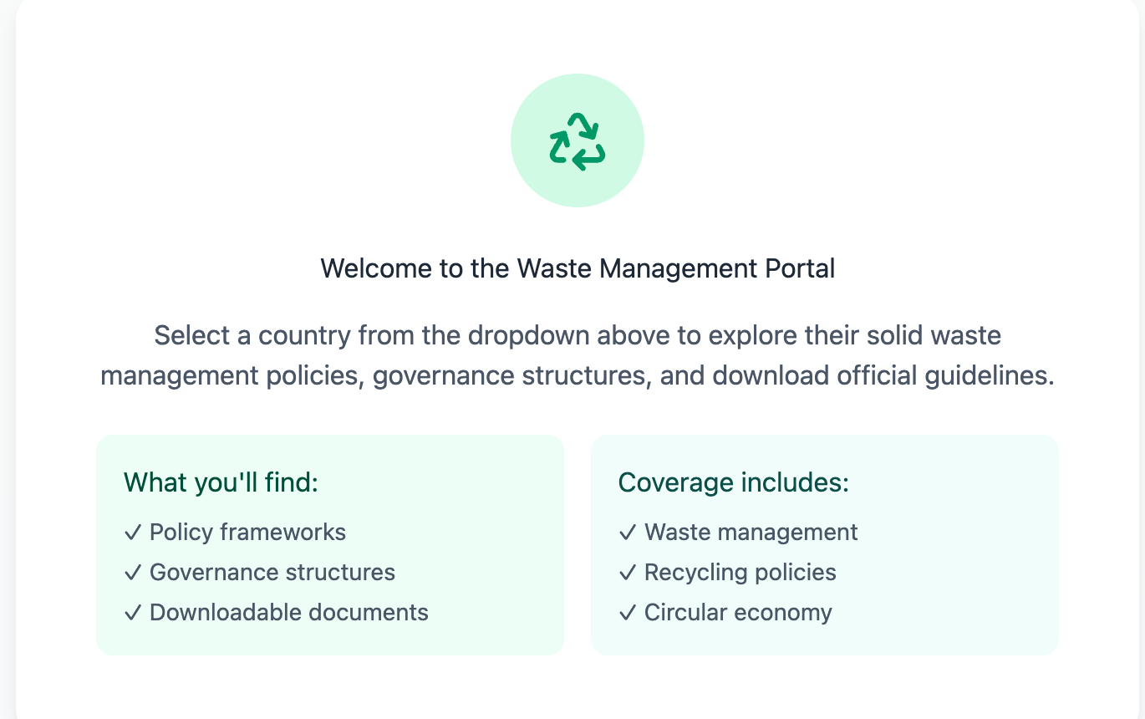

Welcome to the Waste Management Portal

Select a country from the dropdown above to explore their solid waste management policies, governance structures, and download official guidelines.
What you'll find:
✓ Policy frameworks
✓ Governance structures
✓ Downloadable documents
Coverage includes:
✓ Waste management
✓ Recycling policies
✓ Circular economy

